|  |  |
| --- | --- |
| **Subject** | SWA – CS590 |
| **Assignment** | Lab 8 |
| **Date** | 8/21/2021 |
| **Students** | Vo Ngoc Huy Nguyen - 611066 |
| **Professor** | Rene de Jong |

# Lab Assignment 8: Microservice Introduction

**Exercise 1: Spring Boot Config Server**

* Run config server

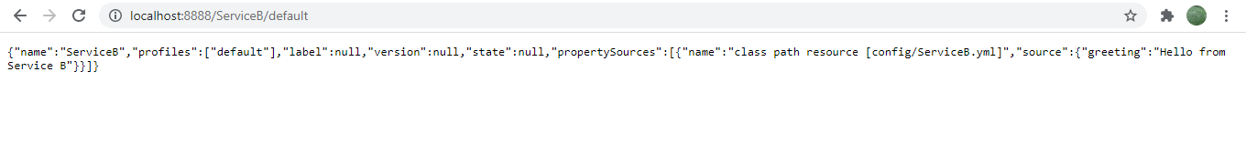

* Run config client Application A:

* Run config client Application B:

Refer attached sources code for details

**Exercise 2: Config server for our webshop**

**All projects:**

* configServer

Config yml files

* Customer Service

* Product service

* ShoppingCart

* Order service

* Running results with Client

Mongo DB database results:

Logs in Mongo DB

Logs in ActiveMQ

Refer attached sources code for details